OPM - SCRD – Release I Assembly Deployment Guide

Revision History
Author | Revision Number | Date
TCSASSEMBLER | 1 | 2/3/2014

Deployment Instructions 3
1. Organization of Submission 3
2. Application Setup 3
3. Ant .Properties File 4
4. Build Scripts Setup 4
5. Database Setup 5
6. Deployment Instructions 6
7. Starting 6
8. Verification 6
8.1. Web Tests 6
8.2. Login 7
8.3. Update all date entries so that auto-format to: MM/DD/YYYY 7
8.4. Account summary update 8
8.5. Period Type update 8
8.6. Interest rate update 9
8.7. Country select other than US 9
8.8. Deposit/redeposit merge 11
8.9. Refund date update. 13
8.10. Update Interest 13
8.11. Frozen mark update 16
9. Resource Contact List 17

Deployment Instructions

Organization of Submission

Folder | Description
conf | Contains application configuration files
lib | Contains dependencies
src | Contains all source files
docs | Contains documentation (this file)
test_files | Contains the test files
log | Contains the test log files
conf/jpa | Contains the JPA mapping and persistence configuration
conf/ejb | Contains the EJB configuration
conf/rules | Contains the business rule definitions
conf/web | Contains the web application configuration files (including spring MVC bean definitions)
conf/ear | Contains application wide configuration (including the datasource definition)
conf/jboss | Contains application changes to the JBoss configuration
src/web | Contains the web application sources
src/java/core | Contains java sources shared across modules
src/java/ejb | Contains java sources for the EJB module
src/java/web | Contains java sources for the front end web application
src/java/tests | Contains java test sources
build-dependencies.xml | Declaration of build dependencies
build.properties | Externalized build configuration
build.xml | Ant build script

Application Setup

The application is tested with the following stack

- Java 6 (http://www.oracle.com/technetwork/java/javase/downloads/index.html)
- JBoss EAP 6.1 (http://www.jboss.org/jbossas/downloads/)
- Ant 1.8.1 (http://ant.apache.org/)
- PostgreSQL 9.2.4 (http://www.postgresql.org/)

The following 3rd party libraries are packaged with the submission
- Drools 5.5
- Spring MVC 3.2.3
- Hibernate 4.2.3
- Joda-Time 2.3
- JUnit 4.10

Ant .Properties File

Property Name | File property is stored | Example Setting
jboss.home | build.properties | D:/Servers/jboss-eap-6.1
loggerName | build.properties | gov.opm.scrd
supervisorRoleName | build.properties | supervisor
defaultPreferenceId | build.properties | 1
log_dir | build.properties | D:/opm_log
postedPendingApprovalStatus.id | build.properties | 1
postedPendingApprovalStatus. name | build.properties | Payment Status 1
redepositPeriodType.id | build.properties | 1
redepositPeriodType. name | build.properties | DEPOSIT
dedepositPeriodType.id | build.properties | 2
dedepositPeriodType. name | build.properties | DEDEPOSIT
csrsRetirementType.id | build.properties | 1
csrsRetirementType. name | build.properties | Retirement Type 1
successCalculationStatus.id | build.properties | 1
successCalculationStatus. name | build.properties | Calculation Status 1
db.driver | build.properties | org.postgresql.Driver
db.url | build.properties | jdbc:postgresql://localhost:5432/scrd
db.user | build.properties | postgres
db.pass | build.properties | 123456

Build Scripts Setup

build.xml – compiles, packages and deploys the application
Main targets:

clean removes all generated files
compile-core compiles shared java sources
compile_tests compiles java test sources
test run the test cases
compile-ejb compiles EJB java sources
compile-war compiles web application java sources
configure-ear performs replacement of values for EAR configuration files
configure-ejb performs replacement of values for EJB configuration files
configure-war performs replacement of values for web app configuration files
db-clear clears the contents of the tables
db-create creates the tables and sequences
db-drop drops the tables and sequences
db-test-data recreates the test data
deploy deploys the EAR artifact
deploy-jdbc-driver copies the jdbc driver module into jboss
dist-core creates the core distribution
dist-ear creates the EAR artifact
dist-ejb creates the EJB distribution
dist-war builds the war file

Default target: deploy

Database Setup

Note: for some steps, you can use the ant script to execute them, but make sure you configure the build.properties first.

- Setup PostgreSQL 9.2.4
- Create the database “scrd” using your client. (you may change the DB name, but update your JDBC URL accordingly)

- Execute script src/sql/create-schema.sql and src/sql/triggers.sql to create the required objects (“ant db-create” will perform the same step)
- Execute script ant db-test-data” to insert test data

Setup Database Driver module on JBoss

- Copy conf/jboss/modules into the modules folder of your EAP installation -${jboss.home}/modules/system/layers/base (“ant deploy-jdbc-driver” will perform the same step)
- Add the following entry to ${jboss.home}/standalone/configuration/standalone.xml just after the h2 driver declaration on the datasources/drivers subsystem

<driver name="postgresql-jdbc4" module="org.postgresql">
<driver-class>org.postgresql.Driver</driver-class>
</driver>

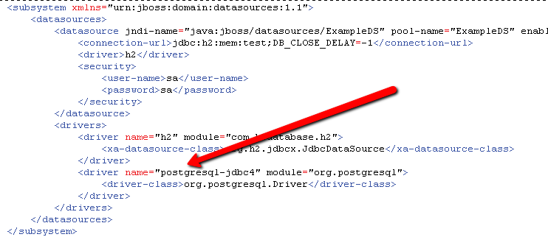

Note: This step can also be done via the jboss command line interface with the following command:

/subsystem=datasources/jdbc-driver=postgresql-jdbc4:add(driver-name=postgresql-jdbc4, driver-class-name=org.postgresql.Driver, driver-module-name=org.postgresql)

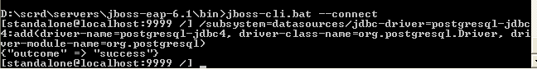

Cleanup scripts: (execute only when done with testing)
• When needed, execute src/sql/clear-data.sql to clear the database tables(“ant db-clear” will perform the same step)
• When needed, execute script src/sql/drop-schema.sql to delete all application objects (“ant db-drop” will perform the same step)

Deployment Instructions

- Modify build.properties to reflect the deployment environment settings. (log_dir must be an existing directory)
- Setup the database as described in the previous section
- Execute “ant deploy”

Starting

Start JBoss. The application is automatically started when the JBoss server is started.

Please note that you may receive a warning (JBAS011054) regarding EAP 6.1 and Spring 3.2.3, you may safely ignore this warning per

https://community.jboss.org/thread/231638?start=0&tstart=0

Verification

Web Tests
When started, open the default URL in your browser http://localhost:8080/scrd/, this should show you the test page for CRUD and to execute the calculation.

Note: you may want to turn on DEBUG logging on the server, just add following line to the server configuration (jboss-eap-6.1/standalone/configuration/standalone.xml) under the logging subsystem – make the changes the before starting the server:

<logger category="gov.opm.scrd">
<level name="DEBUG"/>
</logger>

Make sure you change the threshold of the appender to DEBUG too.

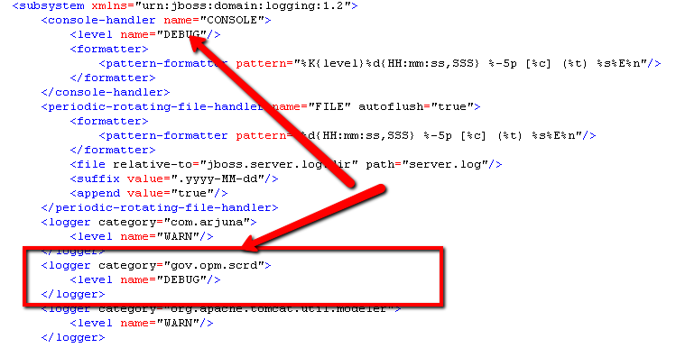

Login
Enter user:user1 and password:123456 to login
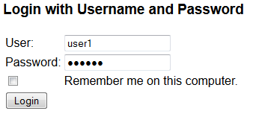

You will be direct to the view account page

Update all date entries so that auto-format to: MM/DD/YYYY
In the view account page, go to Service History tab.
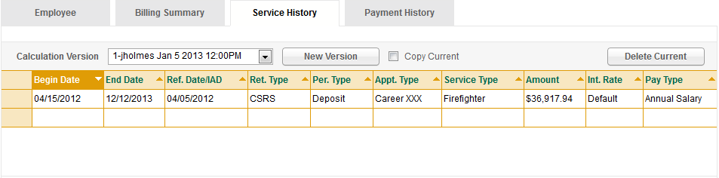
Click on the calculation row, it will become editable.
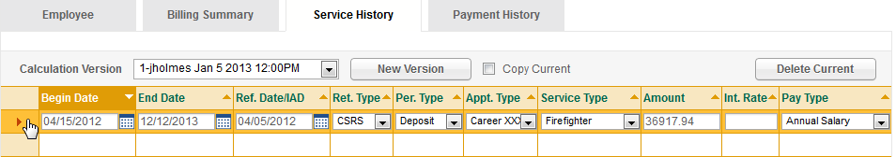
Click begin date, and type 222(which is not a valid date), click another textbox in the row. Verify the begin date is highlight with error.
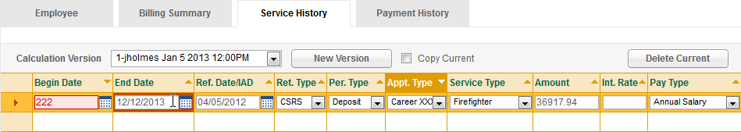
Enter 1/1/1981 in begin date, click another field. Verify the text in begin date become 01/01/1981.

Account summary update
In the account summary section, verify the table display values of all 9 deposit types from the database.
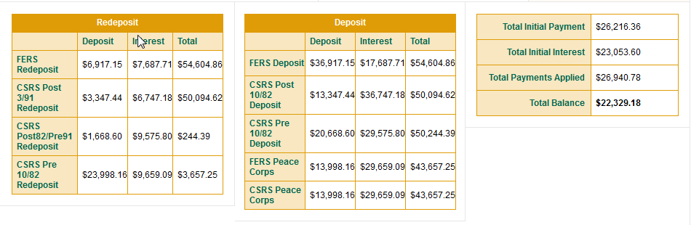

Period Type update
Make sure correct period type values are displayed in the drop down list.
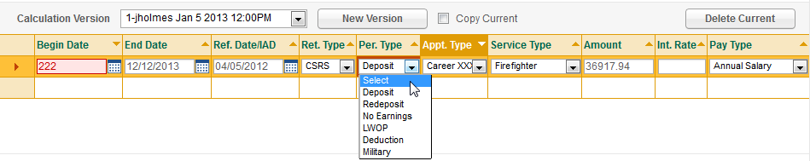

Interest rate update
In the calculation table, verify column Int.Rate exists. Verify Default is displayed.
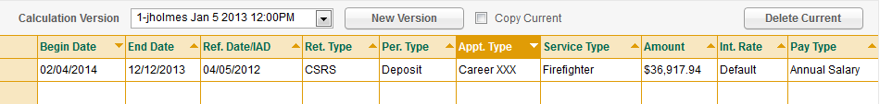

Click the row to enter edit mode. Verify an empty textbox.
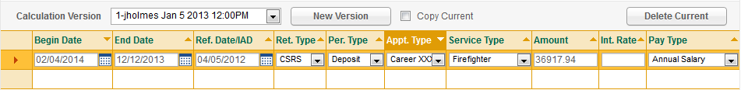

Enter a number in the textbox(make sure you can only enter numbers), click the first column to go back to view mode, make sure the number you entered is displayed.

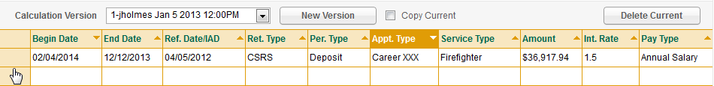

Go to edit mode again, and clear the textbox to waive the interest rate, click the first row to go back to view mode, make sure “Default” is displayed.

Click run calculation, verify in the log file that the interest rate is passed to the backend, or null is passed if Default rate is set.
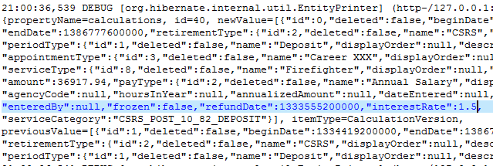

Country select other than US
Click Create New Account Tab
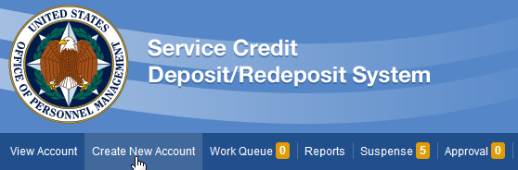
In the form, enter valid values for required fields other than city, state, zipCode.
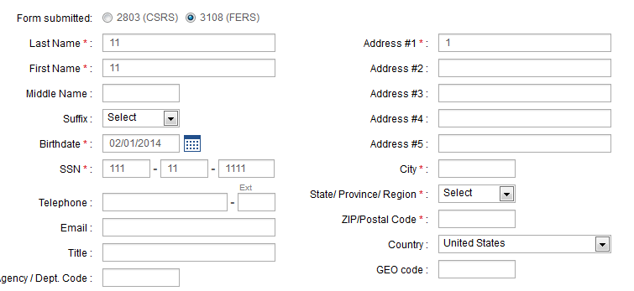
Click next, verify the 3 required field are highlight with error.
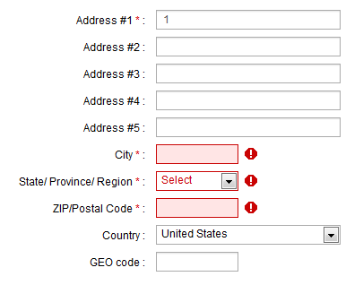
Select a country other than United States, verify all error highlight disappear.
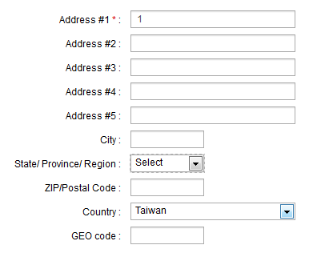
Click next, you should go to the service history page.

Deposit/redeposit merge
You should now at the create new account, step 2 for service history.
Verify there is only one calculation version tab instead of two.
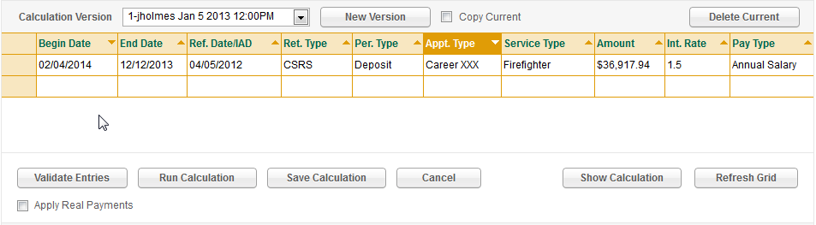
Try create an calculation and press save calculation. And verify the calculation is correct.
Note: currently only a small group of rules can make calculation work. Try the following scenario:
Retire type: CSRS
Period type: Deposit
Service type: FireFighter
Pay type: Annual Salary
Other fields have no restriction.
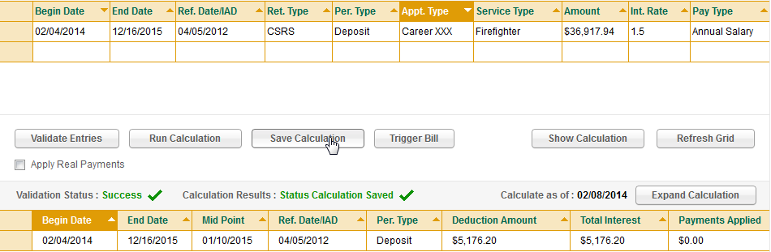
Click Finish on the navigation bar.
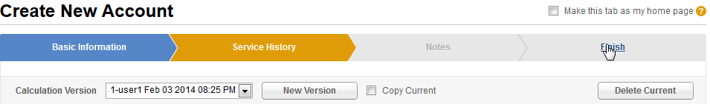
In the finish page, verify there is no tab on the calculation version section, and the information is correct.
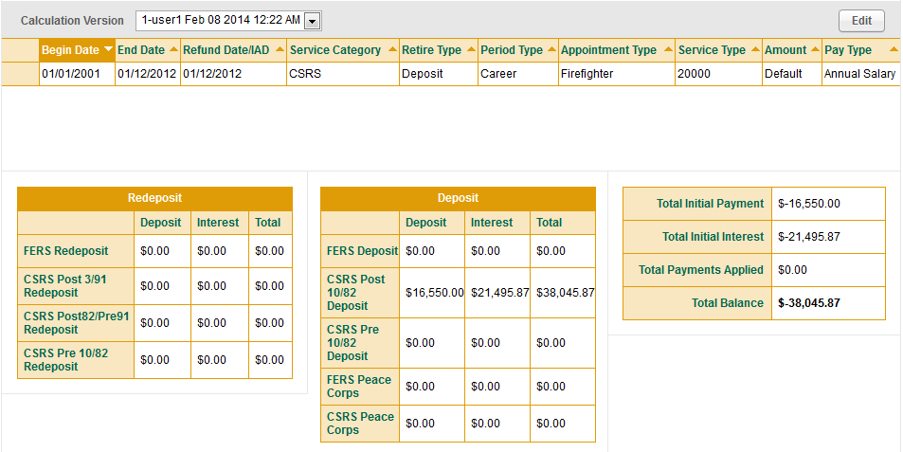
Go to http://localhost:8080/scrd/account/1/detail
Verify again about the merge of Deposit/Redeposit tabs.

Refund date update.

Go to http://localhost:8080/scrd/account/1/detail
In the service history tab, verify the first table has a new column “Ref. Date/IAD”
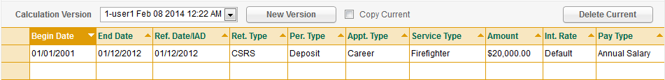
Click run calculation, verify the second table, the 4th column name is “Ref. Date/IAD”, and the value in it and the value in the first table should be the same
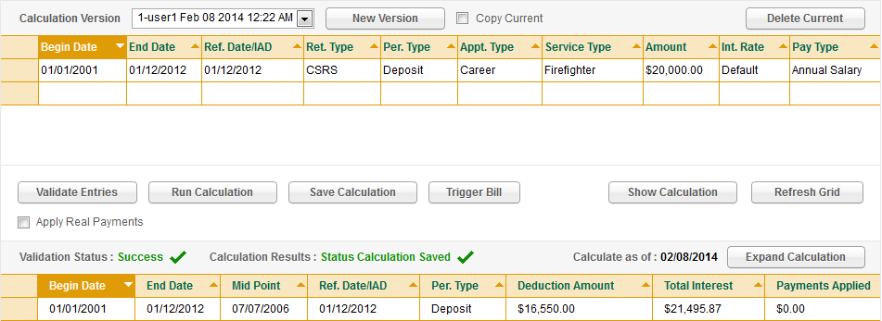

Update Interest
Run ant db-test-data to restore database.
Go to http://localhost:8080/scrd/account/2/detail
In the account detail page, go to Billing Summary tab.
Make sure all buttons are disabled but “update interest” because the account does not have billing information yet.
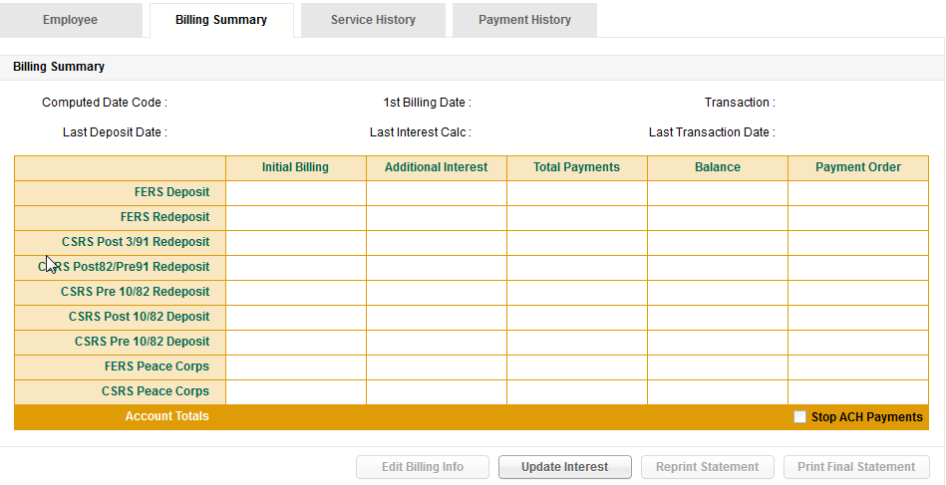

Click update interest, this will pop up alert dialog because this account has no calculation versions.
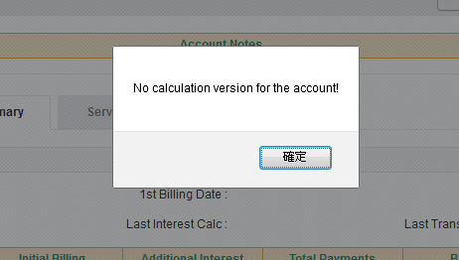

Go to http://localhost:8080/scrd/account/3/detail
In the account detail page, go to Billing Summary tab.
Click update interest, this will pop up alert saying the account has a zero balance.
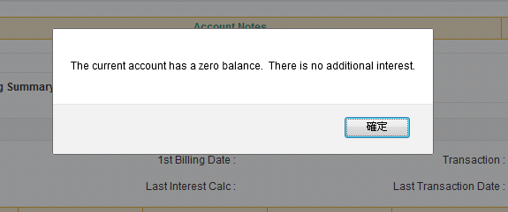

Go to http://localhost:8080/scrd/account/1/detail

In the account detail page, go to Billing Summary tab.
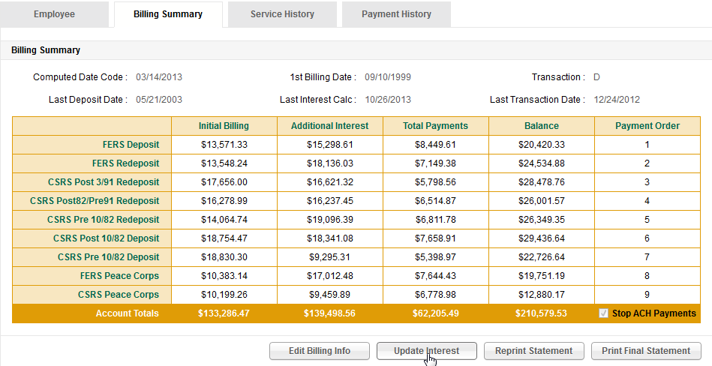
Click update Interest button, click Yes when alert box pop up.
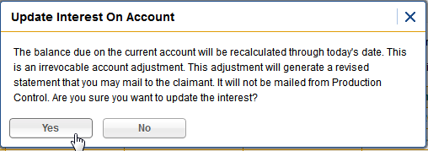
Verify a placeholder for report is displayed.
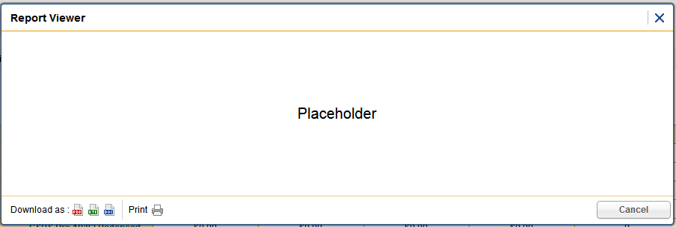
Close the report, verify the billing summary data change.
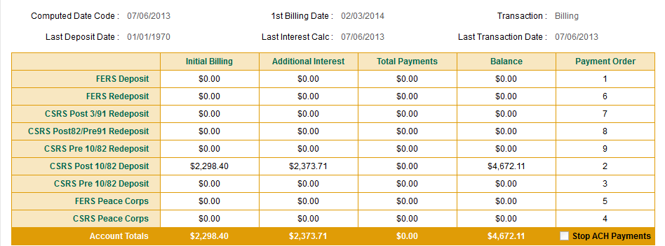

Close your browser, or let session expire, relog in with user2/123456.
Try update the interest, you will get alert for authorization.
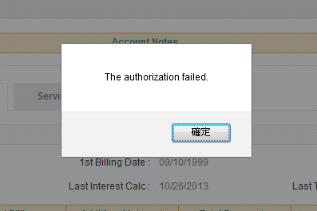

Frozen mark update
Run ant db-calculation-frozen to restore database and set all calculation to have frozen field set to true.

Go to http://localhost:8080/scrd/account/1/detail

In the billing summary tab, click update interest again. Verify that no values in added to the billing summary because the calculation is frozen, and a frozen mark is place at the row.
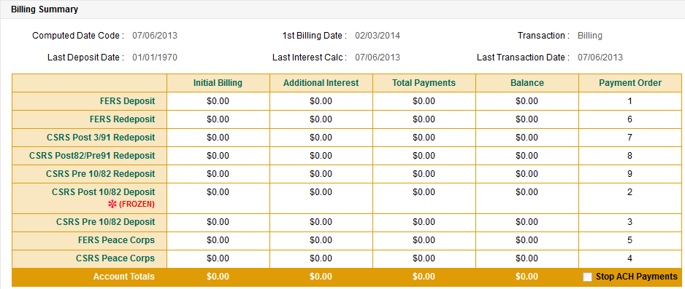

Resource Contact List

Name | Resource Email
TCSASSEMBLER

